**Instructions in Activity:**

1. **Call - Sequence**
2. **Branch - Conditional Execution/Execution will end with Branch Step**
3. **Queue - Parallel execution**

**All the above 3 instructions used to call Used Defined/Predefined activities (API)**

**======**

**Create an Activity To Use Call:**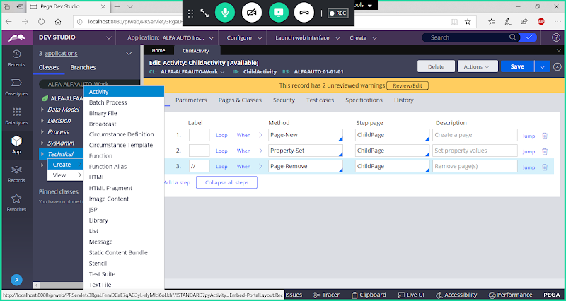

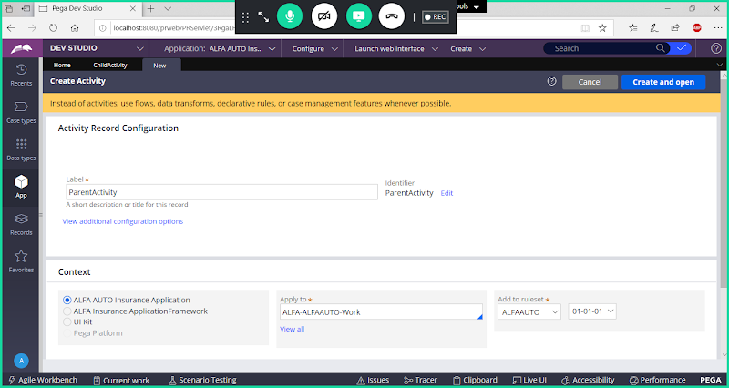

**Open**

**Go to Pages & Classes**

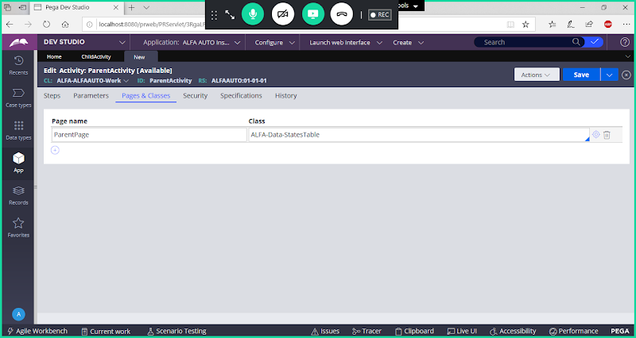

**Go to Steps Tab:**

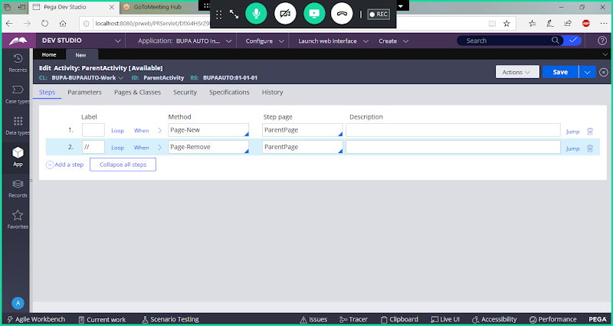

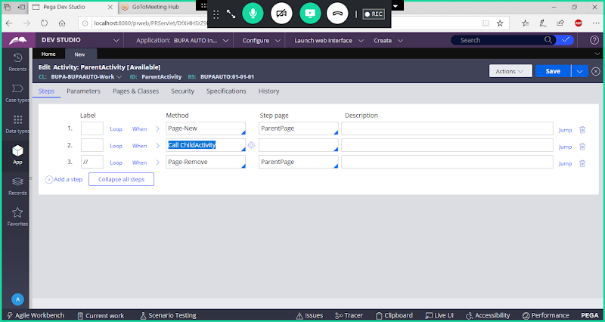

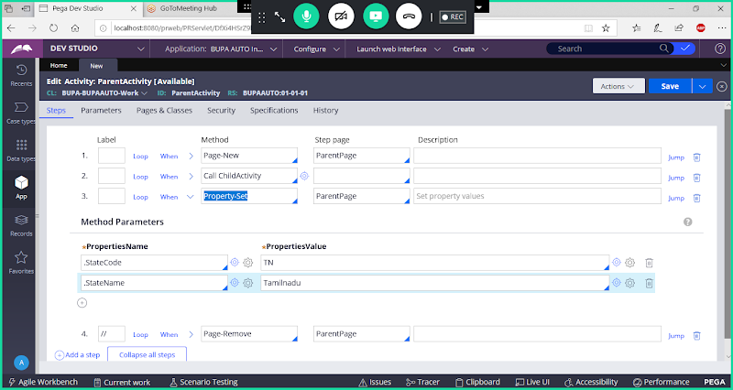

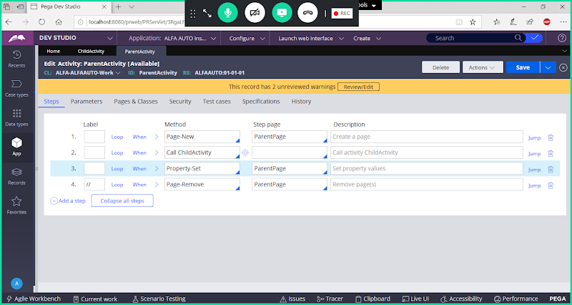

**Save & Run Activity & Debug Using Tracer:**

**Tracer Logs for Call:**

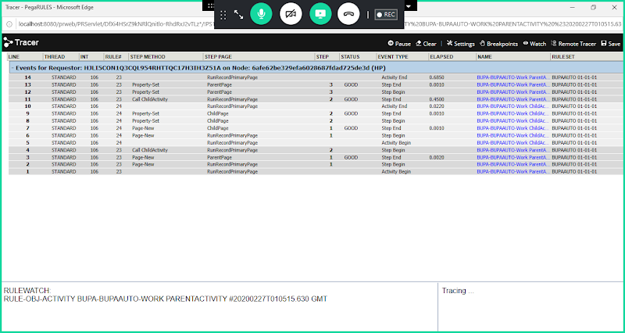

**Purpose of Call:  Call will start the Execution, executes the child Activity ( Called ), come back to parent & executes remaining steps in Activity.**

**In Call Execution is Synchronous.**

**Replace Call with Branch Instruction & Execute Activity:**

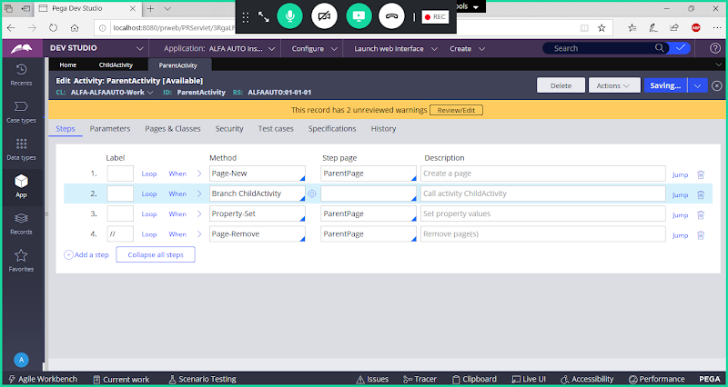

**Save & Run Activity & Debug using Tracer**

**Clear Previous Logs in  Tracer:**

**Tracer Logs for Branch**

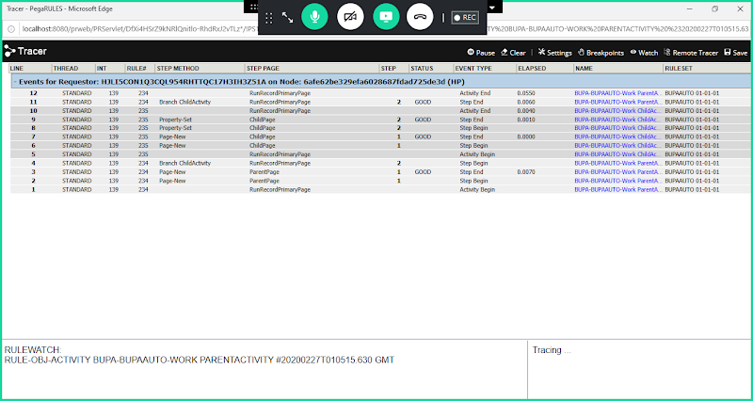

**Branch: Will execute child ( Called ) Activity , Come back to Parent & doesn't executes other steps in Parent Activity after the Branch. The last step in Execution will be always Branch only**

**Execution is Synchronous.**

**--------**

**Scenario1: Tell me which step is last step in execution:**

**Act1:**

**Step1**

**Call Act2**

**Step3**

**Act2:**

**Step1**

**Branch Act3**

**Step3**

**Act3:**

**Step1**

**Step2**

**Call: In above activity Act1 Step3 is last Executed.**

**Scenario2: Tell me which step is last step in execution:**

**Act1:**

**Step1**

**Branch Act2**

**Step3**

**Act2:**

**Step1**

**Branch Act3**

**Step3**

**Act3:**

**Step1**

**Step2**

**Branch: In above activity Activity 1 Step2 is last Executed.**

**Queue: Now Replace Branch with Queue in Parent Activity**

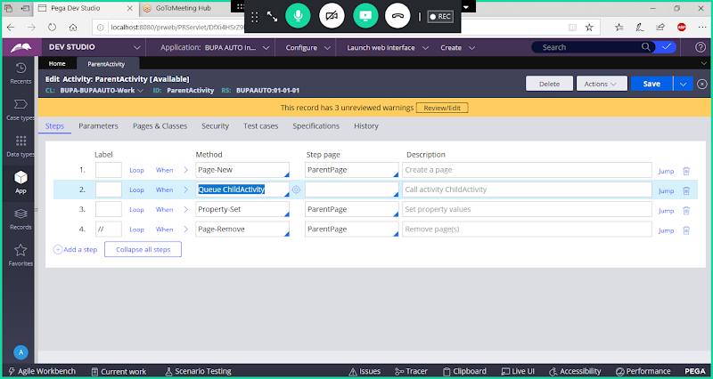

**Save activity & Debug using Tracer**

**Tracer Logs for Queue:**

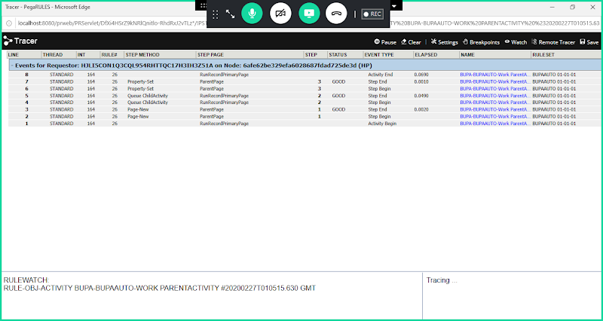

**Queue: Execution Asynchronous (Both Parent & Child Activity executes parallel)**

**Here in Queue Child Activity runs in the background, while parent activity proceeds its execution without waiting for child activity to get completed.**

**=====**